INTRODUCTION TO CYBERSECURITY
FACILITATOR GUIDE

Module Code | 252901001-KM-01,
NQF Level | 4
Credits | 8
Curriculum Code | 252901001
Qualification Title | Occupational Certificate: Cybersecurity Analyst
SAQA QUAL ID | 118986

Name
Contact Address
Telephone (H)
Telephone (W)
Facsimile
Cellular
E-mail

Note to the learner
This Learner Guide provides a comprehensive overview of the module. It is designed to improve the skills and knowledge of learners, and thus enabling them to effectively and efficiently complete specific tasks.
Entry Requirements

- NQF 4
Provider Accreditation Requirements for the Knowledge Module

Physical Requirements
- The provider must have lesson plans and structured learning material or provide learners with access to structured learning material that addresses all the topics in all the knowledge modules as well as the applied knowledge in the practical skills.
- QCTO/ MICT SETA requirements

Human Resource Requirements:
- Lecturer/learner ratio of 1:20 (Maximum)
- Qualification of lecturer (SME):
    - NQF 6 in industry recognised qualifications with 1 years’ experience in the IT industry
    - CYBERSECURITY vendor certification
- Assessors and moderators: accredited by the MICT SETA
Legal Requirements
- Legal (product) licences to use the software for learning and training
- OHS compliance certificate
- Ethical clearance (where necessary)
Module Purpose
The main focus of the learning in this knowledge module is to build an understanding of fundamentals of various computer and network security threats such as identity theft, credit card fraud, phishing, virus and backdoors, emails hoaxes, loss of confidential information, hacking attacks, and social engineering

Topic elements to be covered include
The learning will enable learners to demonstrate an understanding of:
- KM-01-KT01: Introduction to computer and mobile device security
- KM-01-KT02: Various computer and network security threats
- KM-01-KT03: Identity theft
- KM-01-KT04: Adopting good cybersecurity practices
- KM-01-KT05: Safeguard mobile, media and social networking profiles as user
- KM-01-KT06: Protecting computers, accounts and data as user
- KM-01-KT07: Understand security incidents and reporting

Venue, Date and Time:
Consult your facilitator should there be any changes to the venue, date and/or time.
Refer to your timetable
Assessments

The only way to establish whether you are competent and have accomplished the learning outcomes is through continuous assessments. This assessment process involves interpreting evidence about your ability to perform certain tasks. You will be required to perform certain procedures and tasks during the training programmer and will be assessed on them to certify your competence.

This module includes assessments in the form of self-evaluations/activities and exercises. The exercises, activities and self-assessments will be done in pairs, groups or on your own. These exercises/activities or self-assessments (Learner workbook) must be handed to the facilitator. It will be added to your portfolio of evidence, which will be proof signed by your facilitator that you have successfully performed these tasks.

Listen carefully to the instructions of the facilitator and do the given activities in the time given to you.

KM-01-KT01: Introduction to computer and mobile device security

Question
1
Outline the importance of computer and mobile device security

With more than half of business PCs now mobile, portable devices present distinct challenges to network security, which must account for all of the locations and uses that employees require of the company network. Potential threats to devices include malicious mobile apps, phishing scams, data leakage, spyware, and unsecure Wi-Fi networks. On top of that, enterprises have to account for the possibility of an employee losing a mobile device or the device being stolen. To avoid a security breach, companies should take clear, preventative steps to reduce the risk.

KM-01-KT02: Various computer and network security threats

Question
2
Identify and explain the insider security threats
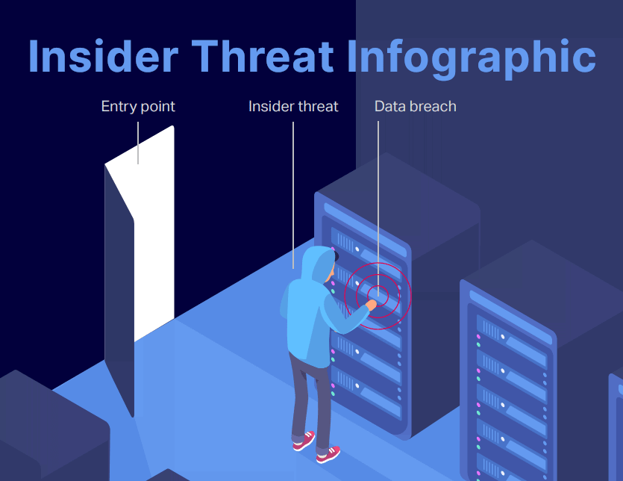
What is an insider threat?
An insider threat refers to a cyber security risk that originates from within an organization. It typically occurs when a current or former employee, contractor, vendor or partner with legitimate user credentials misuses their access to the detriment of the organization’s networks, systems and data. An insider threat may be executed intentionally or unintentionally. No matter the intent, the end result is compromised confidentiality, availability, and/or integrity of enterprise systems and data.
Insider threats are the cause of most data breaches. Traditional cybersecurity strategies, policies, procedures and systems often focus on external threats, leaving the organization vulnerable to attacks from within. Because the insider already has valid authorization to data and systems, it’s difficult for security professionals and applications to distinguish between normal and harmful activity.
Malicious insiders have a distinct advantage over other categories of malicious attackers because of their familiarity with enterprise systems, processes, procedures, policies and users. They are keenly aware of system versions and the vulnerabilities therein. Organizations must therefore tackle insider threats with at least as much rigor as they do external threats
Characteristics of an insider threat
- Involves someone with a degree of privileged access to or knowledge of an organization: Employees are common sources of insider threats, but contractors, vendors, interns, board members or anyone else with non-public levels of access are also insiders.
- Difficult to prevent: As the threat, by definition, comes from inside the organization, security controls focused on external actors will not apply. A firewall, for example, can’t stop an insider threat from accessing the company network, because he or she is already on the company network.
- Difficult to detect: Insiders require some level of privileged access to do their job, but it's often difficult for technology to discern exactly how an insider is using said access. A worker might download a document to review during a transatlantic flight, or they might download it to share with a competitor. Basic access control won’t be able to tell the difference between the two motives.
- Often has a strong motivation. In the case of a malicious insider threat, there is often a very strong motive. An employee who feels he or she was wrongly terminated, for example, may hold a grudge against the former organization. In the most extreme cases, those with an ideological motive may have nefarious intent in mind even when applying for a position at a company in the first place.
Who is at risk of insider threats?
While any organization is susceptible to an insider threat, certain industries tend to experience either more serious or more frequent incidents:
  - Healthcare: Verizon’s 2019 Insider Threat Report found that healthcare organizations were responsible for more reported insider attacks than any other industry. While some of this could be explained by the sector’s unique mandatory reporting requirements, other Verizon research revealed that healthcare was the only industry in which insiders were responsible for a larger share of breaches than external threat actors.
- Financial services: Research from the Ponemon Institute shows that the financial industry spends more than any other on containing, investigating and responding to insider threat risks. Interestingly, anecdotal evidence suggests many insider attacks in the finance industry are actually motivated by grudges.
- Manufacturing: The manufacturing sector has shown up as a particularly noteworthy victim in multiple studies and surveys of malicious insider threats. The proprietary knowledge that’s involved in a variety of critical manufacturing processes has proven particularly alluring to malicious insiders.
- Aerospace and defense: Critical sectors such as aerospace and defense account for some of the most damaging insider threat incidents. Economic espionage, advanced campaigns by nation-state actors, and politically motivated insiders have all played a role in past incidents.
- Government and academia: Organizations such as CISA, the National Institute of Standards and Technology, and the FBI have been particularly active in boosting insider threat awareness within the federal government during the last several years. Public entities of all sizes, however, still remain vulnerable to different types of insider threats.
The Ponemon Institute’s Research also shows that the frequency of insider threat incidents is directly related to an organization’s headcount and that organizations in North America appear to be the most frequently attacked victims.
Types of insider threats
There’s seemingly no end to the variety of ways a privileged insider could do damage — that’s what makes insider threat prevention so difficult. However, most insider threats can be categorized based on their intent:
Turncloaks
Malicious insiders known as turncloaks knowingly take action to harm an organization. The insider could be an employee, a contractor or even a trusted business partner. Turncloaks could be motivated by financial gain, revenge or political ideology. Some perform covert actions such as stealing sensitive documents or proprietary information. Others prefer a path of destruction, wiping databases and leaving a trail of total chaos on their way out the door.
Pawns
In contrast to the turncoat, pawns don’t intend for their actions to have an adverse impact. Some pawns are simply careless, reusing passwords between work and personal accounts or leaving flash drives full of sensitive information at a coffee shop. Others may perform negligent or reckless actions such as circumventing security measures for their own personal convenience. Still, others are completely unwitting participants, falling for phishing scams or other forms of social engineering. Pawns can sometimes skirt the line with a turncoat by knowingly cooperating with an external party, but failing to realize the true implications of their actions.
Moles
Moles operate much like turncloaks, but moles join a company intending to cause harm to the organization. They are very often driven by a strong political motive, whether to a nation-state or fringe cause. Moles are among the most difficult insider threats to detect and are potentially the most damaging.

KM-01-KT03: Identity theft

Question
3
Explain two types of identity theft and how to mitigate them
Scammers use email or text messages to try to steal your passwords, account numbers, or Social Security numbers. If they get that information, they could get access to your email, bank, or other accounts. Or they could sell your information to other scammers. Scammers launch thousands of phishing attacks like these every day — and they’re often successful.
Scammers often update their tactics to keep up with the latest news or trends, but here are some common tactics used in phishing emails or text messages:
Phishing emails and text messages often tell a story to trick you into clicking on a link or opening an attachment. You might get an unexpected email or text message that looks like it’s from a company you know or trust, like a bank or a credit card or utility company. Or maybe it’s from an online payment website or app. The message could be from a scammer, who might
- say they’ve noticed some suspicious activity or log-in attempts — they haven’t
- claim there’s a problem with your account or your payment information — there isn’t
- say you need to confirm some personal or financial information — you don’t
- include an invoice you don’t recognize — it’s fake
- want you to click on a link to make a payment — but the link has malware
- say you’re eligible to register for a government refund — it’s a scam
- offer a coupon for free stuff — it’s not real
Here’s a real-world example of a phishing email:
Image

Imagine you saw this in your inbox. At first glance, this email looks real, but it’s not. Scammers who send emails like this one are hoping you won’t notice it’s a fake.
Here are signs that this email is a scam, even though it looks like it comes from a company you know — and even uses the company’s logo in the header:
- The email has a generic greeting.
- The email says your account is on hold because of a billing problem.
- The email invites you to click on a link to update your payment details.
While real companies might communicate with you by email, legitimate companies won’t email or text with a link to update your payment information. Phishing emails can often have real consequences for people who give scammers their information, including identity theft. And they might harm the reputation of the companies they’re spoofing.
How To Protect Yourself From Phishing Attacks
Your email spam filters might keep many phishing emails out of your inbox. But scammers are always trying to outsmart spam filters, so extra layers of protection can help. Here are four ways to protect yourself from phishing attacks.
Four Ways To Protect Yourself From Phishing
1. Protect your computer by using security software. Set the software to update automatically so it will deal with any new security threats.
2. Protect your cell phone by setting software to update automatically. These updates could give you critical protection against security threats.
3. Protect your accounts by using multi-factor authentication. Some accounts offer extra security by requiring two or more credentials to log in to your account. This is called multi-factor authentication. The extra credentials you need to log in to your account fall into three categories:
- something you know — like a passcode, a PIN, or the answer to a security question.
- something you have — like a one-time verification passcode you get by text, email, or from an authenticator app; or a security key
- something you are — like a scan of your fingerprint, your retina, or your face
Multi-factor authentication makes it harder for scammers to log in to your accounts if they do get your username and password.
4. Protect your data by backing it up. Back up the data on your computer to an external hard drive or in the cloud. Back up the data on your phone, too.
What To Do if You Suspect a Phishing Attack
If you get an email or a text message that asks you to click on a link or open an attachment, answer this question:
Do I have an account with the company or know the person who contacted me?
If the answer is “No,” it could be a phishing scam. Go back and review the advice in How to recognize phishing and look for signs of a phishing scam. If you see them, report the message and then delete it.
If the answer is “Yes,” contact the company using a phone number or website you know is real — not the information in the email. Attachments and links might install harmful malware.

KM-01-KT04: Adopting good cybersecurity practices

Question
4
Outline the importance of adhering to good cybersecurity practices.

Technology used to be expensive and time-consuming to implement and many event organizers chose not to embrace technology because of this. This is not the case any more and there are many cloud based solutions from which to choose with various different pricing options. I believe there is a real risk for event organizers of becoming uncompetitive and having dissatisfied attendees if they choose to ignore the trends in technology.
Online registration software should not just improve the user experience, but also make life easier for the organizer. The advantages of having an online registration facility are:
(1) increase attendance
The speed and convenience of an online registration facility makes it more likely for participants to take action than having to go through a fax, post or phone registration process. Online payment and automated email reminders also makes it more likely for participants to commit to attending the event.
(2) increase revenue
Because of increased attendance and the 24 hour availability, convenience and speed of secure credit card payments, you would have access to funds much sooner than traditional methods.
(3) save time and money
Online registration and participant management functionality dramatically reduces the time spent on managing an event by reducing or eliminating the need for manual registration entry, invoices & receipts, email & telephone communication, printing, and manually compiling reports. Having a payment facility also further reduces time spent on tracking participants and it is possible to issue refunds through the system.
(4) help eliminate errors
The manual process of keying in information, communicating with participants and compiling documents increases the risk of errors that can lead to dissatisfied clients.
(5) real time information
Whenever you need to make changes to your program, pricing and other information, you can easily update this online and it would immediately reflect on the system. You will also have real time information at your fingertips like specific event attendance figures, outstanding payments and be able to control how many participants may register for a particular item. Most systems also allow you to export data to a spreadsheet application like MS Excel.
(6) customer satisfaction
A professional looking event website and an easy registration & payment process makes it more likely that you would get repeat customers and referrals.

KM-01-KT05: Safeguard mobile, media and social networking profiles as user

Question
5
Describe the importance of safeguarding mobile and media devices.
Best Practices: Safe Social Networking
Safety Tips for Social Networking
Social networking sites like Facebook and Twitter can be a great way to connect with friends. But there are some social networking safety tips you should always keep in mind.
- Manage your privacy settings. Learn about and use the privacy and security settings on your social networking sites. They help you control who sees what you post and manage your online experience in a positive way. You'll find some information about Facebook privacy settings at the bottom of this webpage.
- Remember: once posted, always posted. Protect your reputation on social networks. What you post online stays online. Think twice before posting pictures you wouldn't want your parents or future employers to see. Recent research found that 70% of job recruiters rejected candidates based on information they found online.
- Build a positive online reputation. Recent research also found that recruiters respond to a strong, positive personal brand online. So demonstrate your mastery of the environment and showcase your talents.
- Keep personal info personal. Be careful how much personal info you provide on social networking sites. The more information you post, the easier it may be for someone to use that information to steal your identity, access your data, or commit other crimes such as stalking.
- Protect your computer. Security start with protecting your computer. Install Antivirus software. Keep your operating system, web browser, and other software current. You can use the Pitt Software Update Service to automatically download the latest security updates for Windows.
- Know what action to take. If someone is harassing or threatening you, remove them from your friends list, block them, and report them to the site administrator.
- Use strong passwords. Make sure that your password is at least eight characters long and consists of some combination of letters, numbers, and special characters (for example, +, @, #, or $).
- Be cautious on social networking sites. Even links that look they come from friends can sometimes contain harmful software or be part of a phishing attack. If you are at all suspicious, don't click it. Contact your friend to verify the validity of the link first.

KM-01-KT06: Protecting computers, accounts and data as user

Question
6
Identify measures of protecting computers, accounts and data
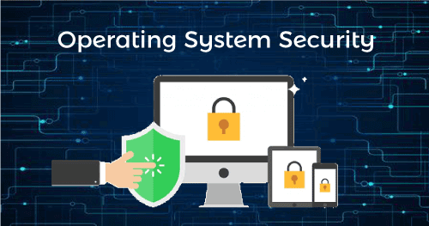
The term operating system (OS) security refers to practices and measures that can ensure the confidentiality, integrity, and availability (CIA) of operating systems.
The goal of OS security is to protect the OS from various threats, including malicious software such as worms, trojans and other viruses, misconfigurations, and remote intrusions.
OS security typically involves the implementation of control techniques that can protect your assets from unauthorized modification and deletion or theft.
The most common techniques used to protect operating systems include the use of antivirus software and other endpoint protection measures, regular OS patch updates, a firewall for monitoring network traffic, and enforcement of secure access through least privileges and user controls.
This is part of our series of articles about sandboxing.
What are Common OS Security Threats?
Here are a few of the most common threat vectors that can affect an operating system.
Malware
Malware is short for malicious software, which encompasses a range of attack vectors such as viruses, worms, trojans, and rootkits. Malware is injected into a system without the owner’s consent, or by masquerading as legitimate software, with the objective of stealing, destroying or corrupting data, or compromising the device.
Malware can also replicate, allowing it to spread further in a corporate network and beyond. Malware attacks often go undetected by the target user, allowing for the quiet extraction of sensitive data. In other cases attackers silently “herd” compromised devices into botnets and use them for criminal activities such as distributed denial of services (DDoS) attacks.
Denial of Service Attacks
A Denial of Service (DoS) attack is intended to clog a system with fake requests so it becomes overloaded, and eventually stops serving legitimate requests. Some DoS attacks, in addition to overwhelming a system’s resources, can cause damage to the underlying infrastructure.
Modern DoS attacks are waged by a distributed network of thousands or millions of bots (automated agents)—this is known as distributed denial of service (DDoS), and can be extremely difficult to mitigate due to its huge scale.
An example of a DoS attack is the repeated use of system requests in a tight loop, or a “syn flood” in which the attacker sends a large number of network requests, requiring the server to acknowledge each one, and exhausting its resources.
Network Intrusion
Network intrusion occurs when an individual gains access to a system for improper use. There are several types of network intrusion depending on the type of intruder:
- Careless insiders—authorized users who neglect to follow security policies or best practices, causing exposure of sensitive assets.
- Malicious insiders—authorized users who misuse their privileges for malicious indigence.
- Masqueraders—external individuals who pose as legitimate users, exploiting the account or credentials of an authorized user to gain access to the system.
- Clandestine users—attackers who penetrate the system by gaining supervisory control and going around access controls.
Buffer Overflow
The main function of a buffer is to temporarily store data. Each buffer has a capacity of data it can hold. During a buffer overflow attack, the buffer or other temporary data stores are overflowing with data. When the buffer overflows, the program attempting to write the data may overwrite other memory locations containing important information.
Threat actors look for buffer overflow vulnerabilities, which they can exploit to inject scripts that help them hijack the system or crash it.
How Can You Ensure Operating System Security?
Here are a few ways you can improve operating system security in your organization.
Authentication Measures
Authentication involves matching an identified user with the programs or data they are allowed to access. All operating systems have controls that can be used to verify that users who run a particular program are authorized to do so.
You can use the following techniques to authenticate users at the operating system level:

  - Security keys: keys are provided by a key generator, usually in the form of a physical dongle. The user must insert the key into a slot in the machine to log in.
  - Username-password combinations: The user enters a username that is registered with the OS, along with a matching password.
  - Biometric signatures: The user scans a physical attribute, such as a fingerprint or retina, to identify themselves.
- Multi-factor authentication: Modern authentication systems use multiple methods to identify a user, combining something the user knows (credentials), something they own (such as a mobile device), and/or a physical characteristic (biometrics).
Using One-Time Passwords
One-time passwords offer an additional layer of security when combined with standard authentication measures. Users must enter a unique password generated each time they log in to the system. A one-time password cannot be reused.
Examples of one-time passwords include:
- Network passwords: An application sends a one-time password to the users via a registered email address or mobile phone number. The user must enter this password to log in to the computer.
- Random numbers: The user receives a card with listing numbers that correspond to matching letters. The OS requires the user to enter the numbers that match a set of randomly generated letters.
- Secret keys: The user receives a device that generates secret keys. The user then enters the secret key into the OS system, which identifies the user credentials associated with the key.

KM-01-KT07: Understand security incidents and reporting

Question
7
Explain the effect of security incidents
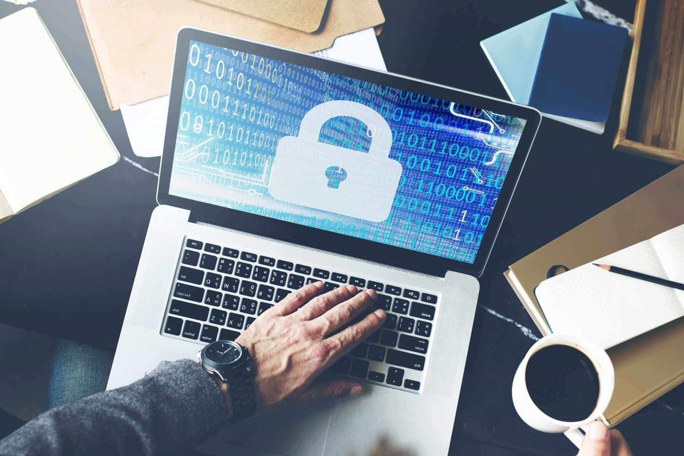
Security breaches and cybercrimes are becoming ever more sophisticated, which turns data protection strategy into a key factor for your business survival. Unexpected hardware failures can render your services unavailable to users and become a true disaster if you don’t have a comprehensive data protection solution in place. Even a simple human error such as unintentional modification or deletion of data may totally disrupt your daily operations. Whatever happens, your ability to quickly handle an emergency situation can help you reduce downtime and thus minimize damage, both financial and reputational. This is exactly why having a carefully developed incident response and disaster recovery plan is so important.

What Is Incident Response?
Incident response can be defined as a set of measures you may take to cope with various kinds of security breaches. Also referred to as IT incidents and security incidents, such events are to be handled in a way to reduce recovery time and costs. To mitigate risks and be prepared for as wide a range of events as possible, you need a detailed and comprehensive incident response plan. This is a set of procedures and actions to be taken when a security breach is revealed. An incident response specialist is supposed to ensure a uniform approach and make certain that none of the outlined steps are skipped. Another important task is to determine where the problem comes from in order to prevent similar incidents in the future. Finally, it is important to regularly update the incident response plan to make sure it addresses both the ever-evolving cyber threats and current needs of your infrastructure.
Types of Security Threats
One of the key principles of incident response and disaster recovery is to carefully develop a plan of actions to cover as many recovery scenarios as possible. Naturally, the key point is to do this before a disaster strikes and such a plan is urgently required. To begin with, you need to take an attentive look at the types of security incidents. Some of the most common ones are as follows:
- DDoS attack
The aim of a distributed denial-of-service (DDoS) attack is to disrupt services and traffic of a target server, network, or website. To carry out an attack, one needs a network of computers infected with malware, or a botnet. The attacker controls bots remotely and sends them the necessary instructions. During a DDoS attack, machines in a botnet start sending simultaneous requests to the target. The flood of malicious traffic can potentially slow down or completely crash the target system. If successful, a DDoS attack renders the service unavailable to users and often results in significant financial damage, as well as the loss or theft of sensitive data.
- Malware and ransomware
Malware is a broad term that refers to viruses, worms, spyware, and other types of malicious programs. In some cases, it can act in a relatively inoffensive way (change screen background or delete files), but sometimes it remains hidden and steals sensitive information. Ransomware is a subset of malware, and the key difference is that the system’s user receives a notification with a demand to pay a ransom. As an example, the victim may find their disks or files encrypted, while the attacker normally promises to restore the machine to its previous state after they receive the payment.

Cybersecurity professionals insist that companies should never pay in such cases. On our part, we emphasize that an adequate backup solution is an effective weapon against ransomware. After all, the main reason why a victim might pay a ransom is because they don’t have an alternative.
- Phishing
This is a form of cyber fraud with its purpose being to access personally identifiable information (PII). As a rule, attackers use social engineering techniques. The victim might receive an email or text, or come across a social media post containing a link to a page where the visitors are asked to submit their personal details. The key idea is to make the victim believe that they are dealing with a reputable entity like a bank, government agency, or legitimate organization. Incident response in the event of a phishing attack should include both preparation and post-incident phases. It is also important to educate your colleagues so that they can recognize the signs of a phishing attempt and avoid putting your network at risk.
- Insider threat
Security threats of this type come from people related to the workflow of an organization, such as its employees, former employees, third parties, contractors, business associates, and so on. In most cases, their main motivation factor is personal gain. However, sometimes malicious insiders want to harm an organization and disrupt its services out of revenge.
A common scenario is when data is stolen on behalf of external parties, such as competitors or business partners. Careless workers who mishandle data or install unauthorized apps pose a threat as well. In other words, you are to carefully analyze all the possible attack vectors to design comprehensive incident response and disaster recovery plans. Once again, training your employees and implementing a set of security procedures are two important steps which can help protect your corporate network.
Incident Response Plan vs. Disaster Recovery Plan: What Is the Difference?
Put simply, an incident response plan should be incorporated into a disaster recovery plan. These are two components of a comprehensively developed data protection strategy. A common mistake is to create these two plans independently. The right practice is to develop, deploy, and test them as a complex of measures to protect data security and integrity. At the same time, even though the objectives of incident response and disaster recovery plans are related, they are not the same.
The key difference between incident response and disaster recovery plans lies in the type of events they address. As explained above, an incident response plan refers to the scope of actions to be taken during an incident. It defines an incident response team’s roles and responsibilities to ensure smooth running of incident response processes. In turn, a disaster recovery plan focuses on bringing your production environment back to an operational state after an incident occurs and successfully recovering from any caused damage.

